**Programming Challenge #2 (25 points) – Due 3/21 on or before 10:00pm**

**Objectives**: **for loop, and if/else if** statements

|  |
| --- |
| **Important instructions:**   * *All programs must include comments at the top of your program: your name,* the class name (CSIT 575)*, program name and* ***the program description (purpose of the program).*** * *Copy and paste your* ***program code*** *and* ***output*** *in Part B of each program. Note: Use snipping tool to snip the output.* * *Once it is done, save and submit this word file via Canvas.* |

**CharacterCount.cpp**

Write a program counts the number of letters, digits, spaces and symbols in the first 30 input characters.

***Input validation:*** *the program must handle the singular or plural of the correct answers.*

**Hints:** use <cctype> header; use cin.get()

**Sample run 1**

Enter your text: 1234 567 !@#$%^ cvbnm,./ 45678

Input contained:

5 letters.

12 digits.

9 symbols.

4 spaces.

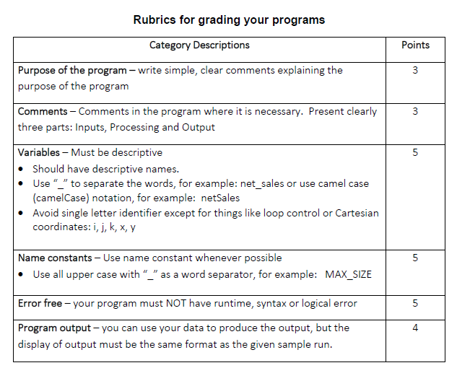

**Part B: Copy and paste your program (source) code and the outputs after this line.**

++++++++++++++++++++++++++++++++++++++++++++++++++++++++++++++++++++